### Take a peek into Ms Aqilah’s PreK Classroom November 24–December 5

**Please send to school a large box (Uhaul x- large box will due) big enough for a couple of children to sit in comfortably and foil paper. We will use it for our science project to begin on Tuesday inshaAllah.**

On Friday, December 5th the children may come to school as any fiction or nonfiction character.

**\*\*\*No School November 27th & 28th\*\*\***

*I’m so excited about being able to take the children to the computer lab for reinforcement lessons in Language Arts, math, science, art and social studies once a week inshaAllah on [www.ABCmouse.com](http://www.ABCmouse.com) I have created cute avatars for each student and sent home a notification along with your child’s free classroom linked account activation information.*

**\*\*\* A spare modem is needed for the computer lab to connect more than one computer to the internet. If anyone has a spare modem or wireless computers please contact us! ☺**

*Please bring an item from home that begins with the sound of letter T and/or I on* ***Thursday December 4th*** *only. No other toys are permitted at school any other day ☺*

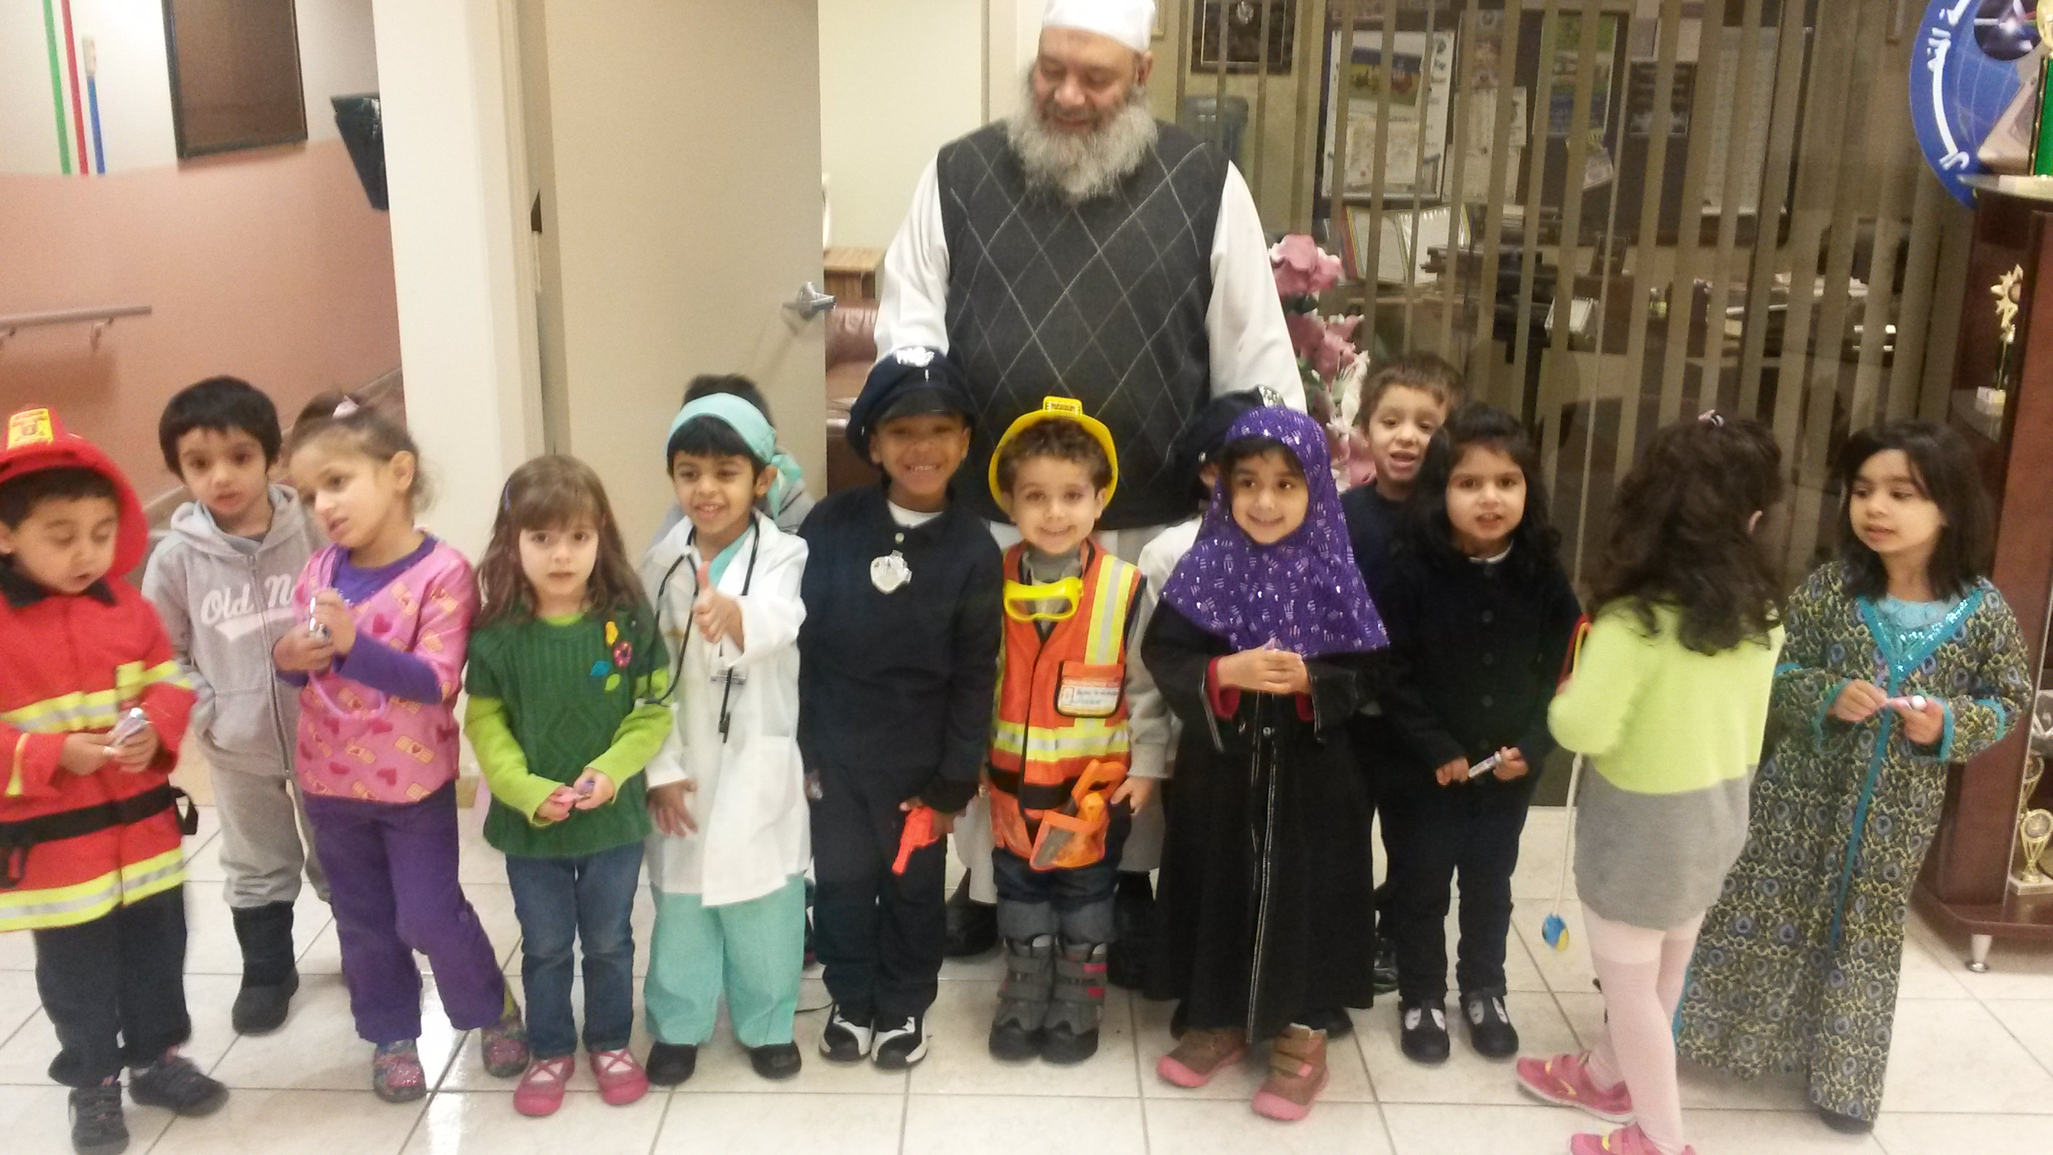

**Monday and Wednesday will be days for the homework sheets to go home. Please leave those sheets in your child’s folder; they will be collected on Friday.**

**Students will begin to receive FREE personal pan pizza hut coupons for submitting their homework weekly. Please remind your child for encouragement ☺**

**\*\*\* two week newsletter\*\*\***

As Salaamu Alaykum!

We had so much fun during our community helper days! The children were absolutely adorable on Friday dressed as little community helpers. MashaAllah, I am very proud of our precious gems. This week we will introduce the “Imagination Station” theme and continue covering the theme until Dec. 5th. The children will learn about different fiction/ nonfiction characters along with their qualities. We will have fun with different fairy tales and stories of real heroes such as the prophet 3layhi wa salem.

For science we will be exploring outer space and will have fun and educational activities about space and rockets (Allah created everything as a subcategory).

Be sure to visit our class webpage: <http://alminhaalearlychildhoodcenter.weebly.com/pre-kindergarten-green.html> for updates & pictures of the activities we have in class ☺

The children will be introduced to the letter T & I.

They will review the sounds and identify words or items that begin with the letter sounds and connect the beginning sounds in the word to the letter name.

We will introduce the concept of above and below.

The students will work on the numbers 4, 5 &6. InshaAllah they will learn the concept and proper way to write the numbers 4, 5 &6 ☺

The students will be taught rhymes, poems and participate in fun/educational activities regarding fairy tales, what is an imagination? What is real? What is pretend?

We are still working on everyday duas i.e (before eating and going to the bathroom). Practice at home helps reinforce what they learned at school.

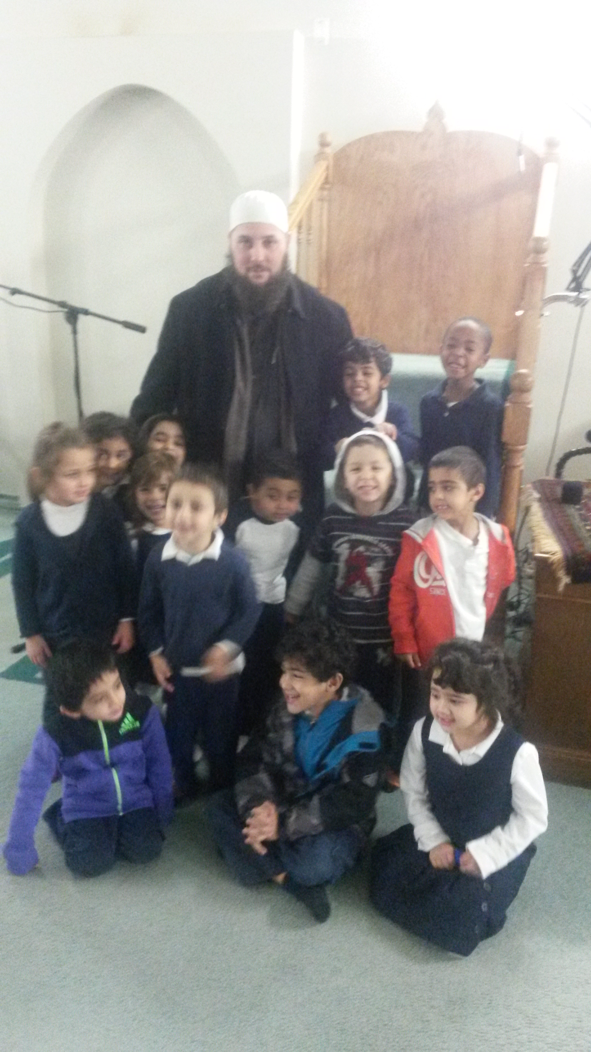

x