### Take a peek into Ms Aqilah’s PreK Classroom November 17–21

**Please send to school a large box (Uhaul x- large box will due) big enough for a couple of children to sit in comfortably and foil paper. We will use it for our upcoming science project next week inshaAllah.** Also please support our can drive and have your child bring a can good a day to be donated this week. ☺

*On Friday November 21st we will talk about the different community helpers we discussed while dressing like one!* ***Please send your child to school dressed as one of the community helpers (paramedic, doctor, nurse, Imam, chef, police officer, fire fighter, crossing guard, teacher etc.)***

*Please bring an item from home that begins with the sound of letter R on* ***Thursday*** *only. No other toys are permitted at school any other day ☺*

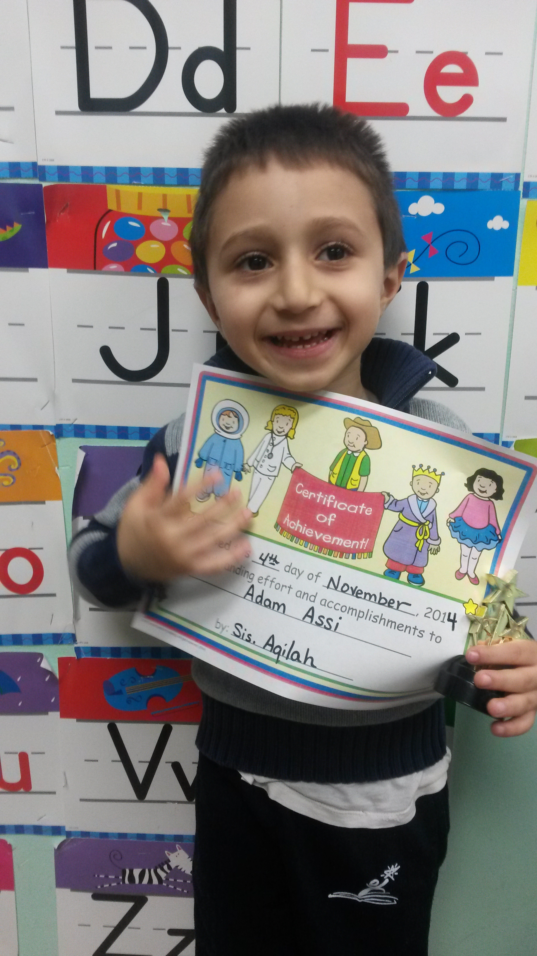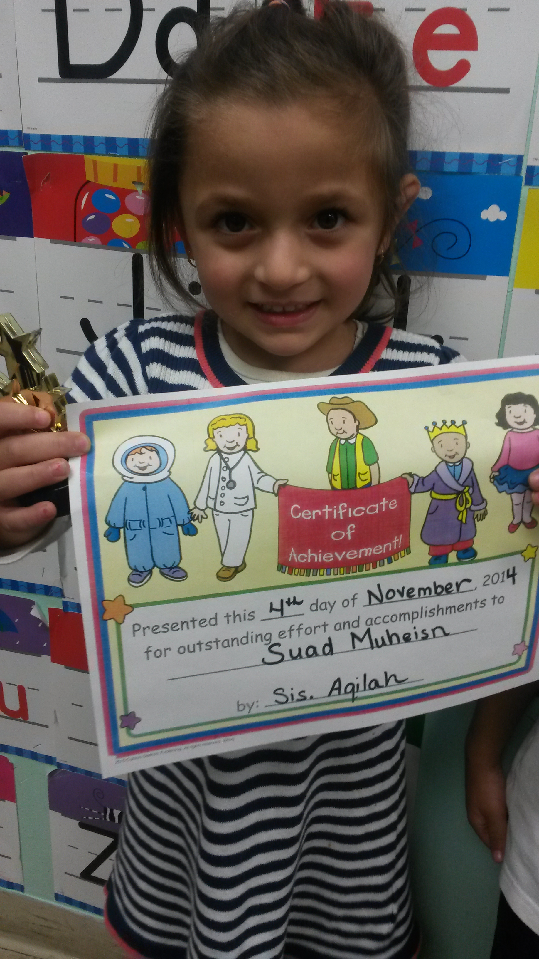

**Monday and Wednesday will be days for the homework sheets to go home. Please leave those sheets in your child’s folder; they will be collected on Friday.**

**Students will begin to receive FREE personal pan pizza hut coupons for submitting their homework weekly. Please remind your child for encouragement ☺**

As Salaamu Alaykum!

During this theme we will introduce other community helpers to the children and describe their jobs and how they are affective in our lives. We had a great field trip to Pizza Hut and I am very proud of our little Chefs mashaAllah! Be sure to visit our class webpage in the ECC section of the alminhaaacademy.com for pictures of the activities we have in class ☺

The children will be introduced to the letter R. They will review the sound and identify words or items that begin with the letter sound and connect the beginning sound in the word to the letter name.

We will introduce the concept of positions (in front, middle and behind). The students will begin working on the number 4, the concept and proper way to write the number 4 inshaAllah ☺

This will be our final week reviewing all of the community helpers inshaAllah. One of the main community helpers that we will be talking about this week is the Imam. We will visit the masjid on Monday inshaAllah and talk with Br. Adam about the Imam's duty as a community helper.

The students will sing the recently taught rhymes, poems and participate in fun/educational activities regarding all of the community helpers reviewed, the qualities of all the community helpers and their duties.

We are still working on everyday duas i.e (before eating and going to the bathroom). Practice at home helps reinforce what they learned at school.

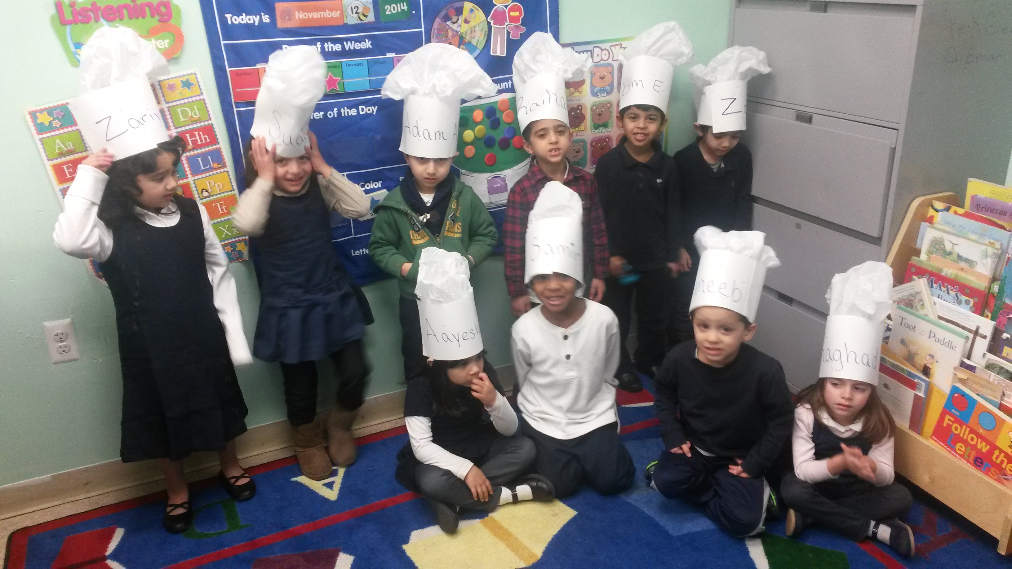

x