Take a peek into Ms Aqilah’s PreK Classroom November 10–14

**Please remember to help provide our class with a gallon of water, spoons, 5 oz cups, medium latex gloves and toilet wipes.**

**Please have those supplies in as soon as possible inshaAllah. The children use these items everyday and we are running out fast**

*Please be sure to dress your child in uniform every day Monday through Thursday. Friday is a free day where the children may dress in regular clothes.*

***We are going to Pizza Hut on Thursday Nov 13, 2014***

*Please bring an item from home that begins with the sound of letter M on* ***Thursday*** *only. No other toys are permitted at school any other day ☺*

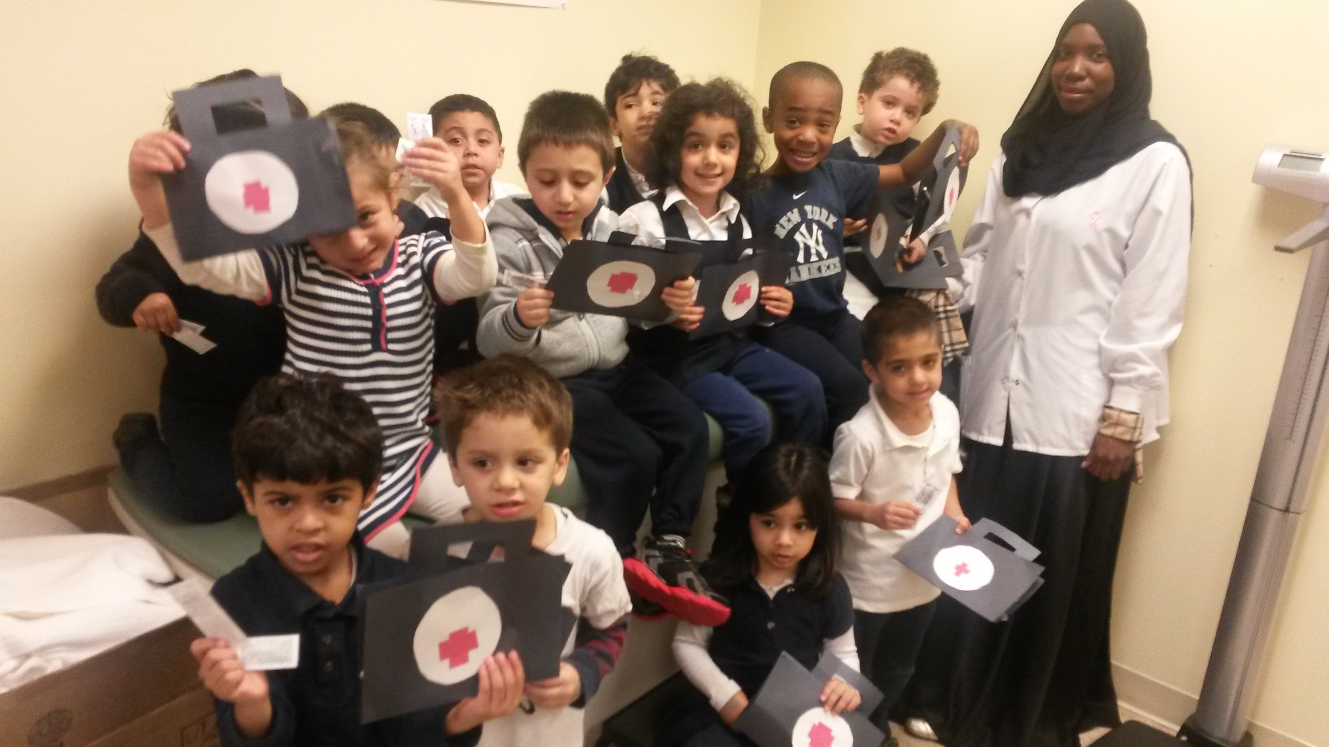

**Monday and Wednesday will be days for the homework sheets to go home. Please leave those sheets in your child’s folder; they will be collected on Friday.**

**Students will begin to receive FREE personal pan pizza hut coupons for submitting their homework weekly. Please remind your child for encouragement ☺**

As Salaamu Alaykum!

During this theme we will introduce other community helpers to the children and describe their jobs and how they are affective in our lives. We are very excited to visit Pizza Hut later this week and experience what it's like to be a chef for the day! Be sure to visit our class webpage in the ECC section of the alminhaaacademy.org for pictures of the activities we have in class ☺

The children will continue to practice writing the letter M. They will review the sound and identify words or items that begin with the letter sound and connect the beginning sound in the word to the letter name. We will also review the letter N and identify/compare the differences when forming the letters.

We will introduce the concept of same & different and review the number 3, the concept and proper way to write the number 3 inshaAllah ☺

The students will be taught new rhymes, poems and participating in fun/educational activities regarding the nurse/doctor, the qualities of a chef and their duties.

We are still working on everyday duas i.e (before eating and going to the bathroom). Practice at home helps reinforce what they learned at school.

Ask your child what they have learned about:

1. What are some things that begin with the letter M? How do you write the letter M & Number 3?
2. Compare some items that are the same and different?
3. What is a Chef and where do they work?
4. What are some ways to stay safe in the cooking areas?

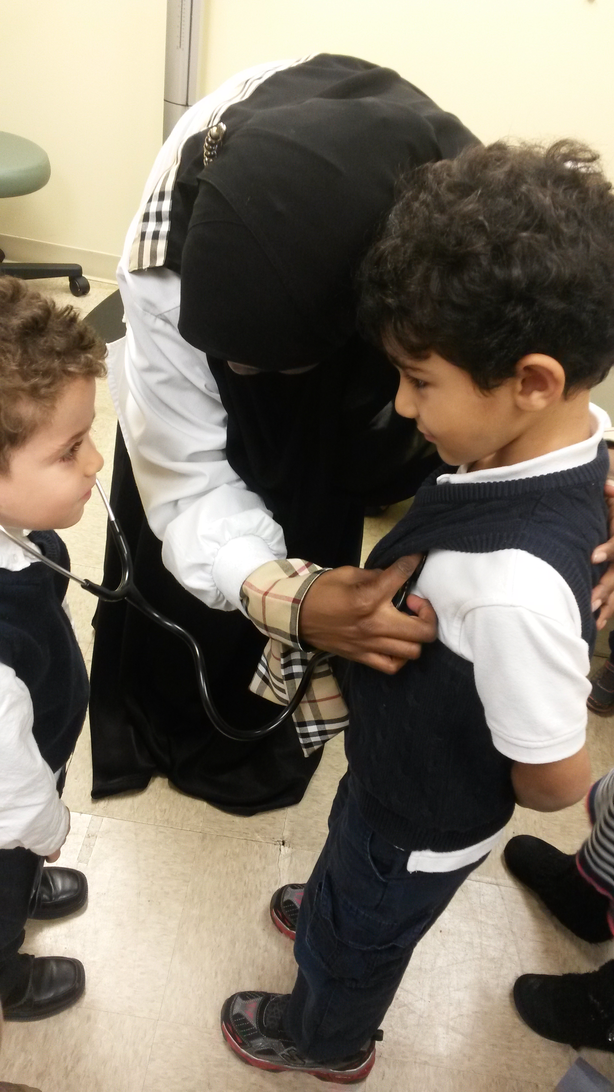

x