Take a peek into Ms Aqilah’s PreK Classroom November 03–05

**Please remember to help provide our class with a gallon of water, spoons, 5 oz cups, medium latex gloves and toilet wipes.**

**Please have those supplies in as soon as possible inshaAllah. The children use these items everyday and we are running out fast**

*Please be sure to dress your child in uniform every day Monday through Thursday. Friday is a free day where the children may dress in regular clothes.*

***Be sure to sign and return the Pizza Hut field trip form along with the pizza fee by Nov 5th :)***

***School is closed Nov 6th -7th***

*Please bring an item from home that begins with the sound of letter M on* ***Thursday*** *only. No other toys are permitted at school any other day ☺*

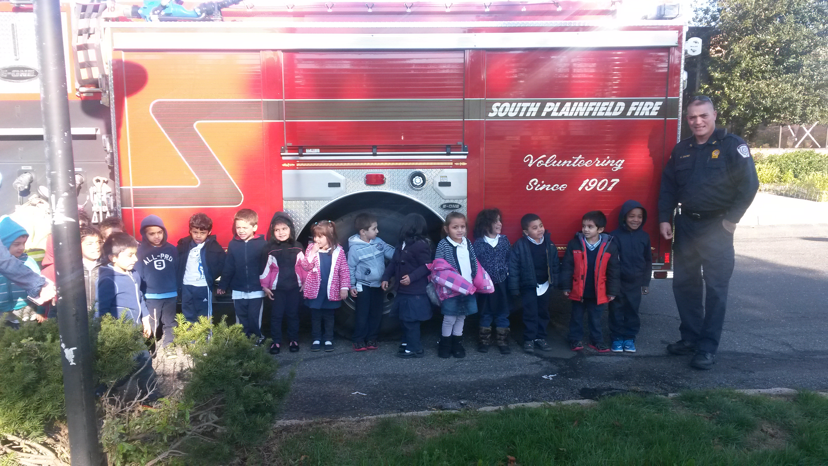

**Monday and Wednesday will be days for the homework sheets to go home. Please leave those sheets in your child’s folder; they will be collected on Friday.**

**Students will begin to receive FREE personal pan pizza hut coupons for submitting their homework weekly. Please remind your child for encouragement ☺**

As Salaamu Alaykum!

What a great week we had! The South Plainfield Fire Safety Unit paid our school a special visit, gave us a fire safety demonstration and let us explore on the fire truck! The looks on some of their faces were simply priceless mashaAllah! Be sure to visit our class webpage in the ECC section of the alminhaaacademy.org for more pictures of this unforgettable day.

We are still working on everyday duas i.e (before eating and going to the bathroom). Practice at home helps reinforce what they learned at school.

This week we will begin our community helpers theme as a branch of our Fire Safety week. During this theme we will begin to introduce other community helpers to the children and describe their jobs and how they are affective in our lives. This week we will talk about the duties and characteristics of a nurse and doctor. Our school nurse will pay us a visit, talk to us about what she does in our community and give us a chance to explore some of the medical equipment used! ☺

The children will be introduced to the letter M. They will review the proper way to write the letter M, review the sound and identify words or items that begin with the letter sound and connect the beginning sound in the word to the letter name.

We will review counting objects and connecting them to the numeral. During this week children will also be introduced to the number 3, the concept and proper way to write the number 3 inshaAllah ☺

The students will be taught new rhymes, poems and participating in fun/educational activities regarding the nurse/doctor, the qualities of a nurse/doctor and their duties.

Ask your child what they have learned about:

1. What are some things that begin with the letter M?
2. What sound does the letter M make?
3. What is a nurse/doctor?
4. What is a theses cope?
5. Where do nurses and doctors work??

x