Take a peek into Ms Aqilah’s PreK Classroom December 8-12

Please provide your child with a healthy snack and make sure he/she has eaten a healthy breakfast before attending school or bring it with your child’s lunch. We will have a morning snack in class and your child may eat a light breakfast at that time if you wish to provide it in their lunch box.

Please remember not to include chocolate, sweets, and large bottles of sweetened milk or sugary drinks in your child’s lunch box. ☺

*I am so excited to begin our weekly visits to the computer lab Friday Dec 12th inshaAllah. We will begin our ABCmouse lessons and you should be able to access your child’s account at home via the access code sent home a few weeks ago. Please feel free to contact me if you need another code ☺*

*We are still covering the planets in Science and we are in need of one more large box in order to build our rocket*

*Please bring an item from home that begins with the sound of letter L on Thursday only. No other toys are permitted at school any other day ☺*

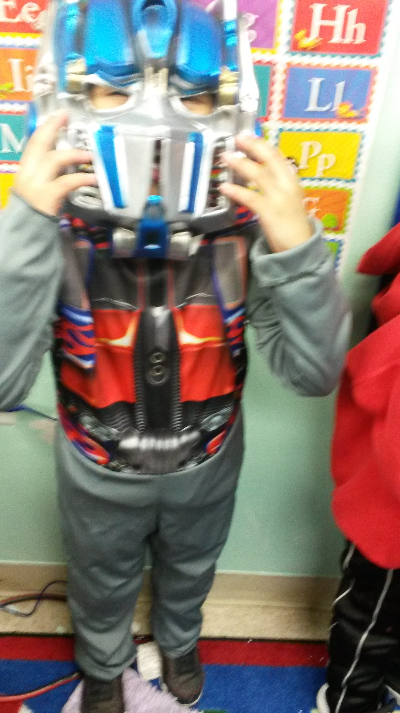

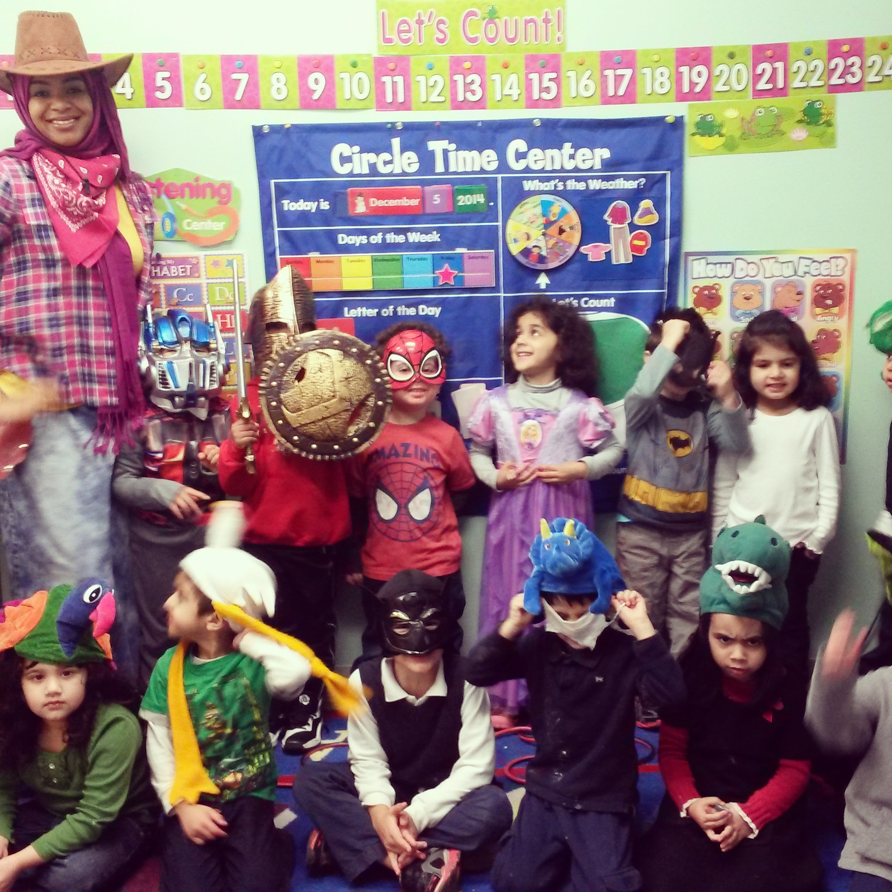

Please **have all treasure fees if never submitted in September and monthly school supplies; as soon as possible ☺**

**Monday and Wednesday will be days for the homework sheets to go home. Please leave those sheets in your child’s folder; they will be collected on Friday.**

As Salaamu Alaykum!

Alhamdolilah, we had a blast during our Imagination weeks. The children enjoyed lots of hands on activities about fiction and nonfiction characters. We ended our week with an Imagination dress up party and it turned out great mashaAllah.

We are still working on everyday duas i.e (before eating and going to the bathroom). Practice at home helps reinforce what they learned at school.

This week we will introduce the “Growing Up Healthy” theme. During this theme we will talk about healthy eating and healthy living. We will incorporate Islamic studies by speaking about the different foods mentioned in the Quraan and different foods that the Prophet sallalho 3layhi w salaam mentioned and/or ate. We will be covering this theme for about 2 or 3 weeks with subcategories inshaAllah. I will be updating you about the subcategories as the weeks go on.

The children will be introduced to the letter L, how to write the letter L, review the letter sound and discover things that begins with the letter. We will review different rhyming words and the concept of right and left. The students will be introduced to the concept of number 7 and learn how to write the number 7.

The students will be taught new rhymes, poems and participating in fun/educational activities regarding food groups, categorizing the food groups, distinguishing the difference between healthy and not so healthy foods.

Ask your child what they have learned about:

1. What sound does the letter L make? (things that begin with L)
2. What are some food items in the meat, fruit and veggie categories?
3. What are some foods that are haraam and why?
4. What are some healthy & unhealthy foods?

